SUB-GRANT
between
Salt Lake Community College
Salt Lake City, Utah
and
College of Eastern Utah
Price, Utah

This agreement is made by and between Salt Lake Community College (herein “SLCC”) and College of Eastern Utah, Price (herein “Sub-grantee”).

Recitals

WHEREAS the United States Small Business Administration (“SBA”) has entered into a cooperative agreement “(Cooperative Agreement”), continuation number 9-603001-Z-0050-14 with SLCC, pursuant to SBA’s Small Business Development Center (SBDC”) program, for the operation of a small business development center network in Utah (“Network”).

WHEREAS SLCC is authorized to maintain a lead center (“Lead Center”) and enter into sub-grant agreements to delegate performance of some of SLCC’s responsibilities under the Cooperative Agreement.

WHEREAS Sub-grantee desires to become a member of the Network and perform some of the Networks responsibilities through a service center and related satellites hosted by Sub-grantee (“Service Center”).

Agreement Terms

NOW THEREFORE, in consideration of the promises hereinafter set forth it is hereby mutually agreed as follows:

- Attachments:

Attachment A - Standard Terms & Conditions and Notice of Award
Attachment B - Budget and Key Personnel
Attachment C - Balanced Scorecard

- Sub-grantee Duties and Responsibilities:

- Compliance with Laws and Regulations: In carrying out the terms of this sub-grant, Sub-grantee will comply with all federal laws, regulations, and policies related to the SBDC program; with terms of the Cooperative Agreement; and with the provisions of applicable OMB Circulars. All of the foregoing is herein collectively referred to as the “Requirements”.

- Office: Sub-grantee will establish a separate, sufficient office space for operation of the Service Center, which space will be readily accessible to and have adequate parking for clients and the general public. The Service Center will be open to the public throughout the year during the normal business hours of the Sub-grantee. Additionally, Sub-grantee will provide evening and weekend assistance, both face-to-face and on-line, as appropriate, to meet local community demands and needs. Office signage will comply with the requirements. The Service Center will provide services to the following counties:

Utah SBDC Regional Centers

Blanding | Cedar  City | Ephraim | Logan | Ogden | Orem/  Provo | Price | St. George | Salt Lake | Vernal
Grand | Beaver | Juab | Cache | Box  Elder | Utah | Carbon | Kane | Salt Lake | Daggett
San Juan | Garfield | Millard | Rich | Davis | Wasatch | Emery | Washington | Summit | Duchesne
 | Iron | Piute |  | Morgan |  |  |  | Tooele | Uintah
 |  | Sanpete |  | Weber
 |  | Sevier
 |  | Wayne

- Personnel: Sub-grantee will employ the key personnel and other personnel identified in attachment B to operate the Service Center. Sub-grantee must obtain pre-approval from the SBDC State Director, Greg Panichello, and the SBA Project Officer for any changes in key personnel. Sub-grantee will ensure that all employees, independent contractors, and volunteers execute annually the conflict-of-interest form required by the Lead enter. Sub-grantee will also ensure that the time and effort of employees are tracked and certified in accordance with the Requirements. All individuals providing counseling services for the Service Center will be in full compliance with the networks counselor certification program.

- Equipment: Sub-grantee will ensure that all equipment purchased with the SBDC program funds are properly tagged, included on an inventory list, and properly secured. Equipment purchased with Federal funds is bound by Federal surplus or sale of property requirements.

- Marketing and Branding: Sub-grantee will utilize systems, including Center IC & EX, to market and promote conferences, trainings, classes and enroll participants in advance thereof and accept online client service requests. Sub-grantee will utilize and maintain a Web site for its SBDC services. Sub-grantee will comply with the requirements, of Utah SBDC policies, guidelines, and standards regarding branding. Proper branding is required on office signage, Web sites, advertisements, publications, and similar items. On materials produced by the Service Center, the Utah SBDC logo and branding will not only be comparable in size to, but distinguished from the branding of the host institution.

- Counseling: Sub-grantee will provide counseling to both current and newest entrepreneurs. Sub-grantee’s counseling clients should be reflective of its area’s demographics Sub-grantee will assist small businesses in solving problems concerning operations, manufacturing, engineering, technology exchange and development, personnel administration, marketing, sales, merchandising, finance, accounting, business strategy development and other disciplines required for small business growth and expansion, innovation, increased productivity, and management improvement. Sub-grantee will make its counseling services available online. Sub-grantee may not charge a fee for counseling. The Service Center will attempt to contact and as appropriate inactivate any client file that has had no activity within 120 days.

- Training: Sub-grantee will provide quality training designed to improve the skills and knowledge of existing and prospective small business owners/managers in its area. Where appropriate, Sub-grantee will utilize educational technology such as computer based instruction, distance learning initiatives, video tapes and other electronic media. Sub-grantee’s training must be coordinated with the SBA project officer. All training materials developed in an electronic format will be made available, upon request, to SBA and all of its resource partners. Sub-grantee may charge reasonable fees to cover program costs associated with trainings. These fees are considered program income and must be used to expand SBDC services and further SBDC program objectives.

- Milestones: SLCC and the Lead Center have negotiated and established, and will continue to negotiate and establish, with the SBA and the state of Utah, goals and objectives (“Milestones”) for the Network and each service center in the Network. These Milestones are formalized in the Cooperative Agreement and a balanced scorecard (“Balanced Scorecard” as set forth in Attachment C). Sub-grantee will support and contribute to the Network’s Milestones in effect during the term of this agreement and any extensions thereof. During the term of this agreement and any extensions thereof, Sub-grantee will use its best efforts to accomplish the specific Milestones set forth in the Cooperative Agreement and Balanced Scorecard for the Sub-grantee’s Service Center. While the Sub-grant agreement is based on a calendar year, Milestones for SBA are based on the federal fiscal, October 1 through September 30, and for the state of Utah on the state fiscal year, July 1 through June 30. SBA may establish or modify Milestones subsequent to the execution of this agreement. If this occurs, Sub-grantee will use its best efforts to accomplish the new Milestones.

- Statewide Initiatives: Sub-grantee will use its best efforts to cooperate with and participate in statewide initiatives established by the Lead Center. including shared marketing, quarterly directors' meetings, program-related conference calls, BizSMAR1'TM, 7-Habits for Small Business, Gaining Focus - 360 Survey, Client Assessment and Dashboard, and High Performance Entrepreneur Action Plan. Sub-grantee will actively participate in the statewide strategic planning process and provide both supporting objectives and detailed projects.

- Resource Development: Service Center personnel will identify other small business resources available in the Service Center's geographical area such as economic development entities, chambers of commerce, Custom Fit, PT AC, MEP, and UStar, and establish relationships and partnerships with these resources to the extent possible. Service Center personnel will also, to the extent possible, establish working relationships with SBA's other resource partners - SCORE and the Women's Business Center. Where possible and practicable, the Service Center will co-locate with such resources.
- Special Projects and Resource Projects: N/A
L. Monitoring and Reporting: Sub-grantee will collect the following economic impact data from its clients: the number of jobs including new jobs created and saved, the number and dollar amount of loans obtained (whether SBA or other), the amount of equity infusions/investments, the amount of increased and saved sales, and the number of new businesses started. The Service Center director will submit a semi-annual and annual financial report to the Lead Center within thirty (30) days of the end of June and December. Whenever possible, all reporting, including the semi-annual and annual report shall be submitted to the Lead Center through the Network's reporting and client tracking system, Center IC and its SharePoint site. The Service Center director will ensure that performance and economic impact data are entered into Center IC within the time parameters established by the Lead Center, generally completing each month's entry by the 9th calendar day of the next month. The Service Center director will submit to the Lead Center at least four (4) success stories and one SBA Award Nomination each contract year. Sub-grantee will support the Utah SBDC's continuous improvement programs, including counselor certification, satisfaction surveys, needs assessments, environmental scans, the annual independent ASBDC Chrisman study, and other efforts, by collecting accurate data, responding timely to requests for information, and working collaboratively to improve the process.
M. Budget and Match: Sub-grantee's budget for operation of the Service Center is set forth in attachment B. The budget sets forth amounts to be spent from the Service Center's federal account, state account, and match account. Sub-grantee must contribute cash to the Service Center's operation in an amount that equals or exceeds fifty percent (50%) of the Funding Allocation. Sub-grantee must contribute cash, in-kind match, and/or indirect match to the Service Center's operation in an amount that equals or exceeds the Funding Allocation. Sub-grantee must expense its federal account, state account, and match account in the same proportion that each account's budget bears to the total budget amount shown in Attachment B until the federal account and state account reach the balances established in the budget, at which time any further expenses must be charged totally to the match account.
- Invoicing: By January 31 and July 20, Sub-grantee must submit an invoice to the Office of Development, Salt Lake Community College, PO Box 30808, Salt Lake City, Utah 84130-0808 for the six-month period ending the last day of the previous month. The invoice must delineate the budgeted amounts set forth in Attachment B, expenditures for the period covered by the invoice, and cumulative expenditures for the calendar year.

- Reimbursement: Sub-grantee shall reimburse to SLCC the amount of any expenditure reimbursed by SLCC and later disallowed by SBA or SLCC because such expense was not made in compliance with this agreement or the Requirements.
- Confidentiality: Unless otherwise required by law, Sub-grantee will not release or disclose confidential if such confidential information is requested in a legal proceeding, Sub-grantee will take necessary precautions and legal actions to protect privileged information.
III. SLCC Duties and Responsibilities
- Reimbursement of Expenses: SLCC will reimburse Sub-grantee for reasonable, necessary, allowable, and allocable expenses incurred in performing this agreement. Such reimbursement shall not exceed $46,000.00 ("Funding Allocation"). SLCC will not be liable for reimbursing any expenses incurred by Sub-grantee in excess of the foregoing amount. Within thirty (30) days of receipt of Sub-grantee's invoices, SLCC will reimburse Sub-grantee for all reasonable, necessary, allowable, and allocable expenses within the authorized amount. Sub-grantee understands that some of the reimbursement funds will come from federal funds provided by the SBA pursuant to the Cooperative Agreement. Sub-grantee further understands that reimbursement from the Cooperative Agreement award is subject to the availability of funds.
- Site Review: The SBDC State Director and the SBA Project Officer, or their designees, will perform a site review of the Service Center to review compliance with the Requirements. The Lead Center will produce a report of the findings and recommendations from the site review, and provide the report to the Service Center director and the Sub-grantee's liaison for the Service Center. The report will delineate areas requiring further action by the Service Center and/or the Sub-grantee ("Action Items'').
- Support: SLCC, through its Lead Center, will provide training and policy guidance to the Service Center and its employees, and otherwise coordinate the efforts of the Network. Lead Center will hold at least three (3) meetings a year for directors of the service centers in the Network.
IV. Sub-grant Term:
This Sub-grant shall be effective from January I, 2009, until December 31, 2009, unless terminated earlier by the provisions herein. SLCC may extend the term of this Sub-grant by written notification of intent to extend issued to Sub-grantee at least thirty (30) days prior to the expiration date of the sub-grant. If extension is acceptable, Sub-grantee will notify SLCC at least seven (7) days prior to the expiration date of the sub-grant.
- Ownership of Work Product:
Any trainings and/or informational materials, such as publications, training materials/guides, online courses, online tools, Web sites, inventions, reports, studies, designs, drawings, specifications, notes, documents, software, and documentation, computer based training models, electronically, magnetically or digitally recorded, and other work in whatever form, prepared for the betterment of small businesses, developed with SBDC resources, will be readily available to the entire Utah SBDC network, the SBA and all of its resource partners at no cost.
VI. Default:
A. Failure to Accomplish Milestones: The Funding Allocation provided by SLCC to Sub-grantee shall be reduced by 1% for each Milestone after the first milestone which Sub-grantee fails to accomplish 75% or more of such Milestone. The reduction will occur in the period following the period in which the shortfalls occur. The penalty assessed under this provision shall not exceed 5% for any given period.
- Failure to Comply with Requirements and/or This Agreement: If Sub-grantee fails to materially comply with the Requirements or a provision of this agreement, and such failure remains unremedied sixty (60) days after written notice from the Lead Center or SBA, then SLCC may, at its sole discretion, terminate this agreement. The annual site review report provided by the Lead Center and SBA pursuant to paragraph III.B above will constitute written notice for purposes of this paragraph as to the Action Items in the report. If Sub-grantee repetitively fails to comply with the Requirements and/or provisions of this agreement, then SLCC may, at its sole discretion and upon thirty (30) days notice without right too cure, terminate this agreement.
- Liability:
Each party hereto agrees to be responsible and assume liability for its own wrongful or negligent acts or omissions, those of its officers, agents or employees to the full extent required by law, and agrees to hold the other party harmless from any such liability. SLCC and other higher institutions is an institution of higher education in the State of Utah and is bound by the Provisions of the Utah Governmental Immunity Act. Each party agrees to maintain reasonable coverage for such liabilities either through commercial insurance or a reasonable self-insurance mechanism, and the method of such insurance coverage or self-insurance mechanism will be reasonably provided to the other party.
VIII. Dispute Resolution:

Both parties agree that, should disputes arise from the interpretation or implementation of this Agreement, responsible representatives of each party shall meet in good faith to seek a resolution. In the event it becomes necessary to adjudicate the terms of this Agreement, the prevailing party shall be permitted to recover from the other party its reasonable costs, attorney fees and other professional fees incurred in the enforcement hereof. In no event shall a party be liable to indirect, special, punitive or consequential damages, in all cases whether foreseeable or not, even if the party has been advised of the possibility of damages.
IX. Entire Agreement:
This Sub-grant, together with any and all attachments herein incorporated by reference, constitutes the full and complete understanding of the parties regarding the subject matter hereof. No modification or alteration of or addition to this Sub-grant shall be effective to bind the parties hereto unless it shall be in writing signed by the parties or their authorized representatives.

SALT LAKE COMMUNITY COLLEGE COLLEGE OF EASTERN UTAH, Price

By:______________________________ By:__________________________________
Drew Mingl Date Ryan L. Thomas Date
Assistant Director of Development President
& Grants

By:______________________________ By:_________________________________
Greg Panichello Date Miles Nelson Date
Director of SBDC Vice President

ATTACHMENT A
STANDARD TERMS AND CONDITIONS

  - Authority: This Sub-grant is entered into pursuant to the authority set forth in §63-56. Utah Code Annotated, 1953 as amended, Utah SLCC Procurement rules. (Utah Administrative Code SR33) and related statutes which permit the SLCC to purchase certain specified services and other approved purchases for the SLCC.

  - Sub-grant Jurisdiction: The provisions of this Sub-grant shall be governed by the laws of the State of Utah.
  - Records Administration: The SUB-GRANTEE shall maintain or supervise the maintenance of all records necessary to properly account for the payments made to the SUB-GRANTEE for costs authorized by this Sub-grant. These records shall be retained by the SUB-GRANTEE for at least four years after the Sub-grant terminates, or until all audits initiated within four years have been completed, whichever is later.
  - Audit Records: The SUB-GRANTEE agrees to grant appropriate state, federal and SLCC personnel access to all records relating to this Sub-grant for audit and inspection purposes, and for the monitoring of services. Such access will be granted during normal business hours or by appointment.
  - Conflict of Interest: SUB-GRANTEE represents that none of its officers or employees are officers or employees of the SLCC, unless disclosure has been made in accordance with §67-16-8. Utah Code Annotated, 1953, as amended.
  - Sub-Grantee an Independent Sub-Grantee: The SUB-GRANTEE shall be an independent SUB-GRANTEE, and as such, shall have no authorization. Express or implied, to bind the SLCC to any agreements, settlements, liability, or understanding whatsoever, and agrees not to perform any acts as agent for the SLCC, except as herein expressly set forth. Compensation stated herein shall be the total amount payable to the SUB-GRANTEE by the SLCC. The SUB-GRANTEE shall be responsible for the payment of all income tax and social security amounts due as a result of payments received from the SLCC for these Sub-grant services. Persons employed by the SLCC and acting under the direction of the SLCC shall not be deemed to be employees or agents of the SUB-GRANTEE.
7. INDEMNITY CLAUSE: Both parties are governmental entities under the "Utah Governmental Immunity Act," Title 63, Chapter 30, Utah Code Annotated. 1953. as needed. Consistent with the terms of this Act, it is mutually agreed that each party is responsible and liable for its own wrongful or negligent acts that it commits or which are committed by its agents, officials or employees. Neither party waives any defenses otherwise available under the Governmental Immunity Act.
8. Equal Opportunity Clause: The SUB-GRANTEE agrees to abide by the provisions of Title VI and VII of the Civil Rights Act of 1964 (42 USC §2000e) which prohibits discrimination against any employee or applicant for employment or any applicant or recipient of services, on the basis of race. religion, color or national origin; and further agrees to abide by Executive Order No. 11246, as amended, which prohibits discrimination on the basis of sex; 45 CFR 90 which prohibits discrimination on the basis of age; and Section 504 of the Rehabilitation Act of 1973, or the Americans with Disabilities Act of 1990 which prohibits discrimination on the basis of disabilities. Also, the SUB-GRANTEE agrees to abide by Utah's Executive Order, dated June 30, 1989 that prohibits sexual harassment in the work place.
9. Separability Clause: A declaration by any court, or any other binding legal source, that any provision of this Sub-grant is illegal and void shall not affect the legality and enforceability of any other provision of this Sub-grant, unless said provisions are mutually dependent.
  - Renegotiations or Modifications: This Sub-grant may be amended, modified or supplemented only by written amendment to the Sub-grant, executed by the parties hereto, and attached to the original signed copy of the Sub-grant.
  - Debarment: The Sub-Grantee certifies that neither it nor its principals are presently debarred, suspended, proposed for debarment, declared ineligible or voluntarily excluded from participation in this transaction (Sub-grant) by a governmental department or agency. If the SUB-GRANTEE can not certify this statement, attach a written explanation for review by the SLCC.
- Termination: Unless otherwise stated the Special Terms and Conditions, this Sub-grant my be terminated, with or without cause, in advance of the specified expiration date, by either party, upon 90 days prior written notice being given the other party. On termination of this Sub-grant, all accounts and payments will be processed according to the financial arrangements set forth herein for approved services rendered to date of termination.
13.Americans with Disabilities Act: Sub-Grantee agrees to comply with requirements of the Americans with Disabilities Act (ADA) 42 U.S.c. § 1201 et seq. and applicable regulations in performing under this Sub-grant. SUB-GRANTEE also agrees to indemnify and hold harmless the SLCC from any and all actions and/or damages which may arise or accrue against the SLCC as a result of SUB-GRANTEE's failure to comply with the ADA in performing under this Sub-grant.

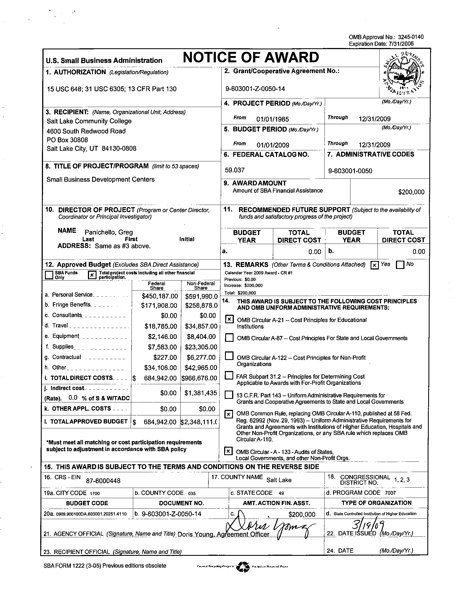
ATTACHMENT B
BUDGET & KEY PERSONNEL

ATTACHMENT C
BALANCED SCORECARD

